Release Notes


H2O America
CM065 – Send Current Account Balance to Invoice Cloud

This work product/document is intended solely for the information and use of the management of H2O America and is not intended to be and should not be used by anyone other than these specified parties.

Author: EY
Creation Date: September 9, 2025
Last Updated: October 21, 2025
Version: 0.1

Document Control

Change Record

Date | Author | Version | Change Reference
2025-Jul-23 | Jayvee Gabriel | 0.1 | Initial Version
2025-Sep-09 | Jayvee Gabriel | 0.2 | Added common library.
2025-Oct-07 | Jayvee Gabriel | 0.3 | Removed the common library and changed the rice ID and description based on CM065 FD.

Reviewers

Name | Position

Distribution

Copy No. | Name | Location
Note to Holders:
If you receive an electronic copy of this document and print it out, please write your name on the equivalent of the cover page, for document control purposes.
If you receive a hard copy of this document, please write your name on the front cover, for document control purposes.

Approved By

Name | Title | Signature | Date

Related Documents

Version # | Related Documents | Release Date
0.1 | H2O - CCS TD - INTC012 – Data Refresh Service.docx | 2025-Jul-14
0.1 | H2OA - CCS TP – CM065 – Send Current Account Balance to Invoice Cloud.docx | 2025-Jul-23
0.1 | H2OA - CCS TD - CM065 – Send Current Account Balance to Invoice Cloud.docx | 2025-Jul-14

Table of Contents
1 Document Control 2
1.1 Change Record 2
1.2 Reviewers 2
1.3 Distribution 2
1.4 Approved By 2
1.5 Related Documents 2
2 Release Notes 6
2.1 CM065 – Send Current Account Balance to Invoice Cloud 6
2.1.1 Business Requirement 6
2.1.2 Solution Description 6
2.2 Defects 6
3 List of Delivered Items 7
3.1 Common Development Configurations 7
3.2 Code Development Configurations 7
4 Special Notes 8
4.1 CM065 – Send Current Account Balance to Invoice Cloud 8
4.1.1 Script 8
4.1.1.1 CM_GetCurBal 8
5 Installation Guide 9
5.1 CCS Installation Prerequisites 9
5.2 Install DB Server Changes 9
5.3 Import CMA 10
5.4 Execute Additional Steps 10
6 Client Configuration/Testing Team Responsibility 11
6.1 CM065 – Send Current Account Balance to Invoice Cloud 11
6.1.1 Feature Configuration 11
6.1.1.1 CM-ICFEAT 11
6.1.2 To Do Type 11
6.1.2.1 CM-DRERR 11
7 Additional Steps 12
7.1 Clear Cache 12
7.2 Flush All 12
7.3 Close Browsers 12
8 Known Issues or Areas of Concern 13
9 Risks & Limitations 13

Release Notes
The following Customer Modifications are included in the H2OA_CM065_001 Delivery:
Reference Number | Description
CM065 | Send Current Account Balance to Invoice Cloud

CM065 – Send Current Account Balance to Invoice Cloud

Business Requirement
CM065 is designed to return person and bill information values related to Account used as input when the service is invoked.

Solution Description
A new service script is developed that will accept the account ID as input and the following fields as output:
- Person ID
- Person Name
- Current Amount Balance
- Total Amount Balance
- Block CC (Defaulted to N)
- Block ACH (Defaulted to N)
- Status (OK or F)
- Status Message

Defects
N/A

List of Delivered Items

Common Development Configurations
The following CMAs are included in this Release:
Reference Number | CMA | Component Name | Type

Code Development Configurations
The following CMAs are included in this Release:
Reference Number | CMA | Component Name | Type
CM065 | CM065_CodeConfig_001.cma | Send Current Account Balance to Invoice Cloud | Service Script

Special Notes

CM065 – Send Current Account Balance to Invoice Cloud

Script

CM_GetCurBal
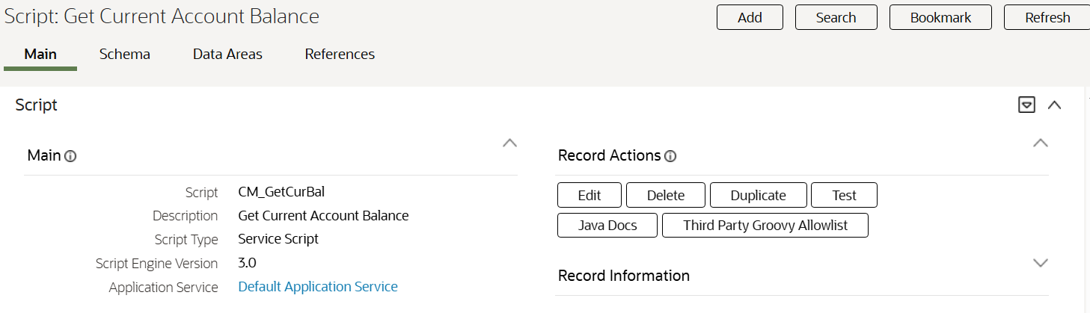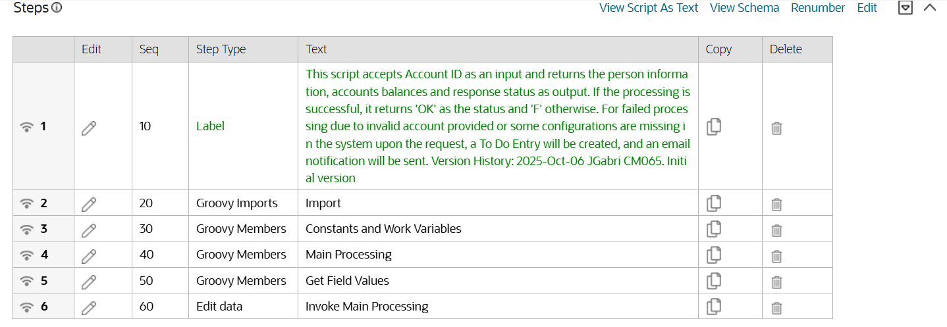

Installation Guide
The Release H2OA_CM065.001 installation package is delivered as a compressed zip file.
This will be extracted with the following directory structure:

H2OA_CM065.001
CMA
Functional Design
SQL
Technical Design
Test Plan

Bringing the base CCS environment to CM Release level H2OA_CM065.001 entails the following steps that must be executed in the following sequence

- CCS Installation Prerequisites
- Install DB Server Changes
- Import CMA
- Execute Additional Steps

CCS Installation Prerequisites
The following base single fixes should be installed on the target environment before applying this Release:
Patch Number | Description

Install DB Server Changes
In order to install the DB changes into a CCS environment, the following steps must be executed:
- Unzip the file.
- Under the H2OA_RICEA.001\SQL folder, make sure it contains the following scripts which should be installed in the same sequence as listed:
- N/A
- Transfer the SQL script files to the appropriate SQL bucket (see Release Management document for further details on identifying which SQL bucket to use).
- Execute the CM-UPSQL batch for each SQL script listed in item #2 above.

Import CMA
In order to import the CMA into the CCS environment, the following steps must be executed in CCS:
- Under the H2OA_CM065.001\CMA folder, make sure it contains the following CMA files which should be installed in the same sequence as listed:
- CM065_CodeConfig_001.cma
- Transfer the CMA files to the appropriate CMA bucket (see Release Management document for further details on identifying which CMA bucket to use).
- Login to CCS
- Go To Admin > M – Migration Data Set Import +
- On the filename, type in the name of the CMA file.
- Set the default status:
  - for add, set the default status to “Approved”
  - for change, set the default status to “Needs Review”
- Click on the ‘Save’ button. This will automatically execute batch F1-MGDIM and F1-MGOPR.
- On Ready to Compare status, review all components. Once all components are either “Approved”, “Unchanged”, or “Rejected”, execute batch F1-MGTPR and then batch F1-MGDIM. This will transition CMA Import to “Awaiting Approval” status.
- Once ready, click on ‘Apply Objects’. This will automatically execute batch F1-MGOAP.
- If all “Approved” items are “Applied” and there is no “Error Applying” item, click on ‘Apply Transactions’. This will automatically execute batch F1-MGTAP.
- Execute batch F1-MGDIM to complete the CMA Import.

Execute Additional Steps
- Additional Steps

Client Configuration/Testing Team Responsibility
This section defines the responsibility of the Configuration/Testing Team in order for the modules (especially those that are Config/Development Tools Related) included in the Release to work completely.

CM065 – Send Current Account Balance to Invoice Cloud
Note: Please apply this configuration if deemed necessary.
Additional Note: Values provided below are sample values only. Please provide the correct values as required by business.

Feature Configuration

CM-ICFEAT
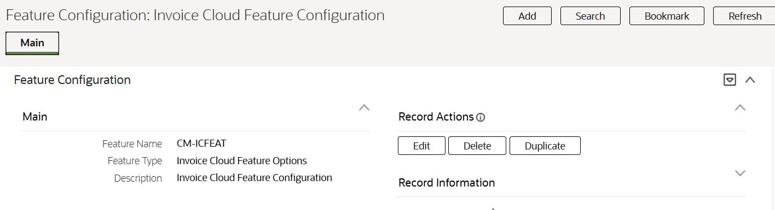

To Do Type

CM-DRERR
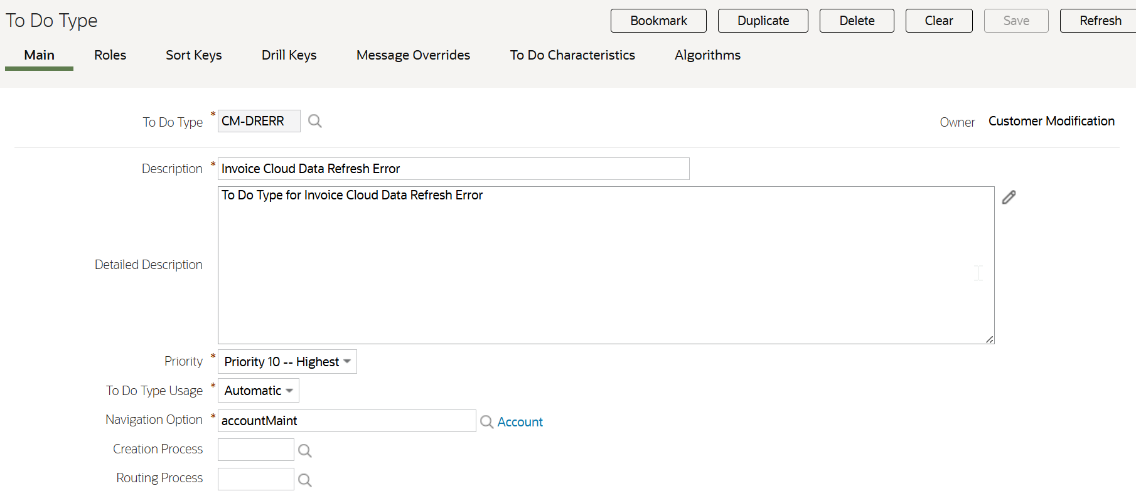

Additional Steps

Clear Cache
Delete the browser’s history.
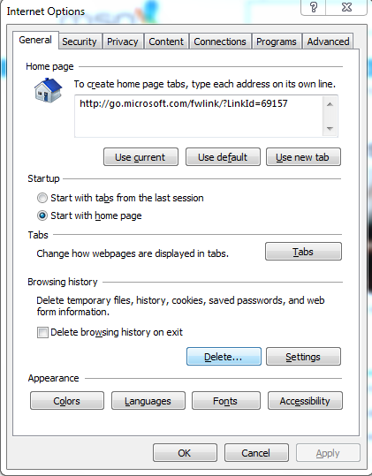

Flush All
http://<ENVIRONMENT>:<PORT>/ouaf/flushAll.jsp

Close Browsers
Note: If the desired changes are not reflected in the system using the Additional Steps, just restart the system.

Known Issues or Areas of Concern
Known Issue | Details

Risks & Limitations
N/A

